Simplified Reference Tissue Model (SRTM) for PET Receptor Studies

Full Reference Tissue method
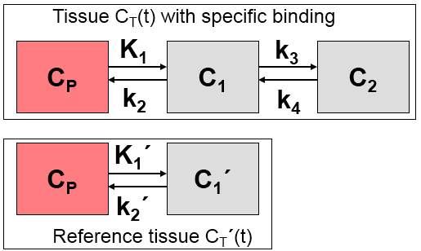
C_Model(t) = R_1 { C_T‘(t) + aC_T‘(t)(*)exp[-ct]+ bC_T‘(t)(*)exp[-dt]}
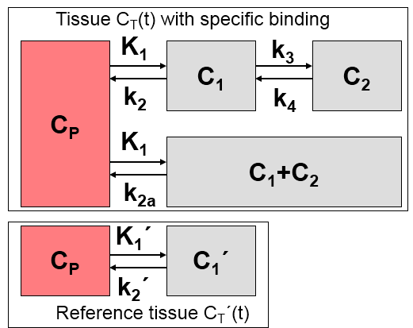
vs. SRTM

3 parameter Model:
Defining
R_1=K_1 / K_1‘
C_Model(t) = R_1C_T‘(t) + {k_2 – R_1k_2 / (1+B_NP)}C_T‘(t) (*) exp[-k_2t/(1+BP_NP)]
Assumptions:
distribution volume is the same for the tissue of interest and the reference volume:
K_1/k_2 = K_1‘/k_2‘
tissue TAC can be fitted by a 1-tissue compartment model
Unknowns:
R1, k2, BP_ND
k_2‘ and k_2a are provided

4 parameter Model:

